NO. 1. EDGE-OF-THE-HAND
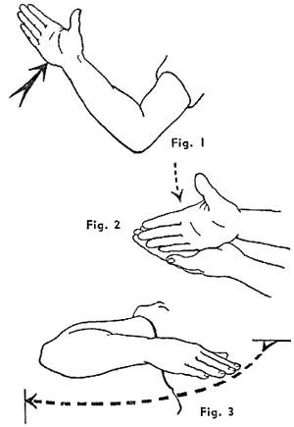

Deliver edge-the-hand blows with the inner (i.e., little-finger) edge of the hand, fingers straight and close together, thumb extended, contact is made with the edge only, about half-wav between the knuckle of the little finger and the wrist, as shown in Fig. 1.

Deliver the blow with a bent arm (never with a straight arm), using a chopping action from the elbow, with the weight of the body behind it. Practice by striking the open palm of your left hand, as in Fig. 2.

There are two ways in which this blow can be delivered:
- Downwards, with either hand;
- Across, with cither hand; the blow always being delivered outwards, with the palm of the hand downwards, never on top (Fig. 3).

Attack the following points on your opponent's body, delivering every blow as quickly as possible:

- The sides or back of the wrist;
- The forearm, half-way between the wrist and elbow;
- The biceps;
- The sides or back of the neck;
- Just below the "Adam's apple";
- The kidneys or base of the spine.

Note. - If your opponent catches hold of you, strike his wrist or forearm; a fracture will most likely result. This would be almost impossible with a blow from a clenched fist.
THE EDGE OF HAND BLOW
FROM ARWROLOGY

Some of the best advice from the time-period on training the edge-of-hand blow comes from Arwrology: All-Out Hand-to-Hand Fighting for Commandos, Military, and Civilians by Gordon E. Perrigard, M.D. (Montreal: Renouf Publishing, 1943) pages 46-50:

Quote:
--------------------------------------------------------------------------------
"THE LITTLE FINGER EDGE OF YOUR HAND"
STRIKE with the little finger edge of your out -stretched hand from the base of your little finger to your wrist. Keep your fingers tightly pressed toegether, and keep your thumb in close too. Your palm nearly always faces down.

This is probably the most deadly natural weapon that an unarmed man possesses if he knows how to use it.

[picture caption]"Make the edge-hand blow snappy. Cut it. Don't just push."

How is it used? Look at your right hand. Straighten out your fingers and thumb. Press them close together. Straighten out your hand, wrist and forearm so they form a straight line. You strike with the little finger edge of the hand from the base of your little finger to about an inch up from your wrist. You deliver the blows with your palm facing down.

Feel the little finger edge of your hand. It is probably soft. It must be hard. How are you going to harden it? Straigten out your hand and with the little finger edge strike repeatedly against any hard surface.

At first these blows may be delivered as light, chopping stokes. As the hand becomes used to the exercise and acquires resistance, more severe blows may be given, until finally a powerful blow with the full, back-hand sweep of the arm is possible. Practice the blows against tables, walls, sand-bags, poles, doors, anything.

EDGE-HAND BLOW EXERCISE

- Face a wall. Keeping your feet still, turn left, bringing your right hand over your left shoulder. Swing to your right, striking the wall at the level of your own neck with the little finger edge of your right hand. Put force into it. Then twist further to your right, bringing your left hand over your right shoulder, keeping your feet still. Swing to your left, striking the wall at the level of your neck with the little finger edge of your left hand. Repeat these actions over and over.

- Now stand with your left side against the wall. Put your left shoulder against it. You are standing at a right angle to the wall. Do not move your feet. Turn left twisting about as far as you can, bringing your right hand over your left shoulder. Unwind and strike the
wall with the little finger edge of your stiffened out right hand. Give a hard blow. You are using your waist muscles to advantage.

Keeping your feet in the same position, turn right and bring your left hand over your right shoulder. Deliver a back edge-hand blow against the wall with your left hand.

- Next stand with your right side against the wall, and repeat the right and left hand blows as above. Rub alcohol on the edge of your hands if they get tender.

- Next stand with your back to the wall, and keeping your feet motionless, practice striking the wall with your left and right hand, twisting the waist with each blow.

These blows have been horizontal. Next come the vertical edge-hand blows.

Vertical Blows.
Facing a wall, turn to your left, just from the waist, keeping your feet still. Give an upward blow against the wall with the little finger edge of your right hand. Then turn left and give and upward blow with your left hand. Repeat.

***
By now you will have an idea of the Edge-Hand blows. Where are you going to hit your opponent with the Edge-Hand blows?

Remember these points
- Either side of his neck (Carotid Sinus)
- The back of his neck, at a point just above the hair line. Why here? Respiratory centres may be affected by a blow in this region.
- Just above and below his nose.
- Along one of his ribs. Here give a horizontal blow, directly under his arms or a little behind his arms. A blow in the region of the kidneys has a shocking effect. This blow si also effective over his heart.
- Up into his crotch. Give a vertical blow here.
- 'Stomach'. Just under his ribs in the front of his body in the mid-line.
- Forearm. Against the top of his forearm at the junction of the upper thirds and lower two thirds (Brachio-radialis muschle and posterior interroseous nerve).

Do the Edge-Hand Blows work?
They have!

An Actual Case

In 1941, Mr. J.J. who is a member of the Society of Arwrologists was walking home one night past a field when he was attacked from behind by four men. One man pulled him around and stuck him a glancing blow on the side of his face.

Mr. J.J. ducked down and swung around delivering a left-edge hand blow against the side of the man's neck (Carotid Sinus).

What happened? The man's arms dropped to his sides and he fell forward, flat on his face. The knock-out was absolutely instantaneous.

Two of the men looked with amazement for a moment, then ran. And when Mr. J.J. turned towards the remaining opponent, he ran too.

With a wave of his hand and a "Good night, gentlemen," Mr. J.J. continued on his way home, smiling confidently.

Another Actual Case

One February evening in 1943, another member of the Society or Arwrologists reports that he was attacked by a man in a cigar store. A back edge-hand blow was delivered under the man's ear. The man fell to the floor, sick to his stomach, hors de combat.

[Special Thanks to Bob Kasper for giving me a rare original copy of Arwrology - J.Sass]
THE EDGED OF HAND BLOW From American Combat Judo
by B. J. Cosneck, 1944

Page12

"The hack is an open hand blow delivered with the little finger side of the hand. The fingers are held extended, stiff and close together. The thumb may or may not be extended. The blow is given with a sharp, swift, hacking movement with such abrupt force that it can either break a bone or paralyze a nerve. Continual practice of pounding the underside of the hand upon a hard, flat object such as a table is advised for toughening the striking surface of the hand. After the hand is thus prepared it can be further toughened by pounding the edge or corner of an object.

When administering the blow, contact is made with that surface of the edge of the hand between the wrist and the base of the little finger. The fingers themselves are not used in striking, because they may slide over each other and make the blow less effective."

Photos from AMERICAN COMBAT JUDO
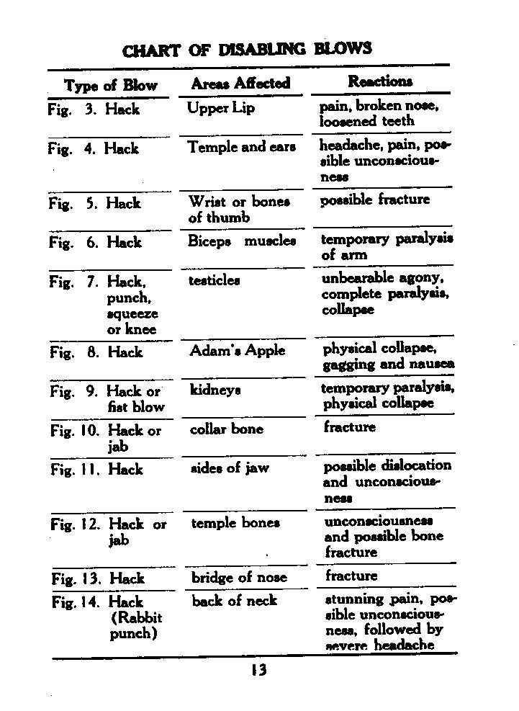
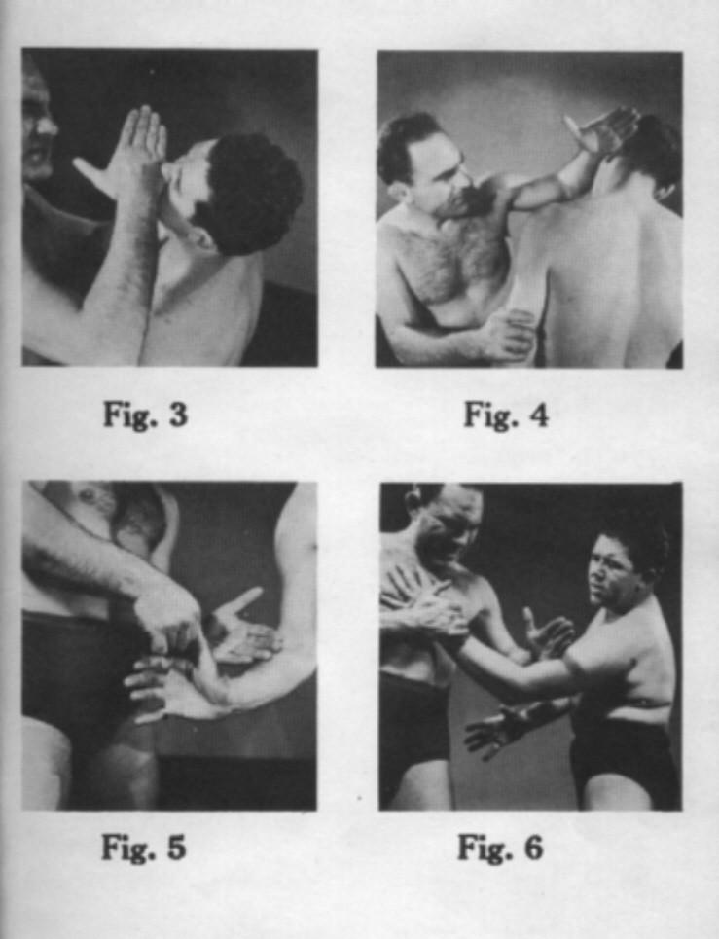
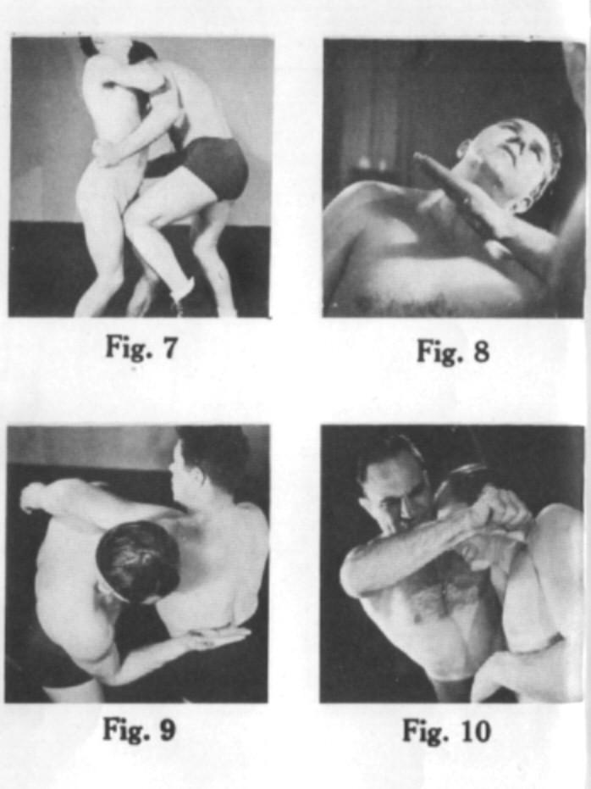
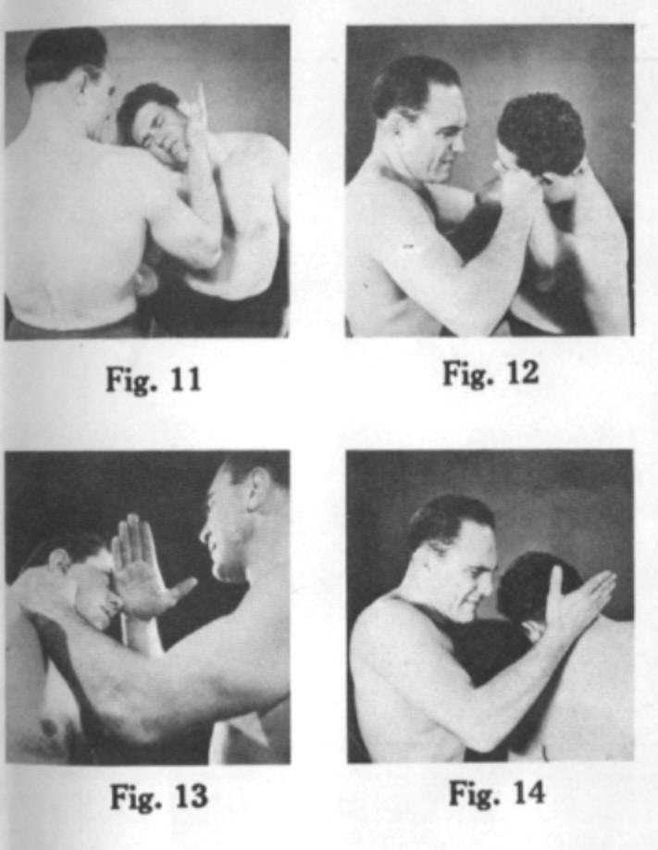

Thanks to "gnarlmaster"
THE EDGE OF HAND BLOW From Combat Judo
by Staff Sergeant Robert L. Carlin, USMC, 1945

No. 1--- EDGE OF HAND

The edge of the hand is sharp and penetrates the nerve centers. Therefore, it is a very dangerous and effective weapon to use against an opponent.

Hold the hand rigid with thumb extended, fingers straight and close together, hit opponent with edge of hand from the first knuckle of the little finger to the beginning of the wrist.

Always hit with the arm bent at the elbow Never hit with a straight arm as you lose power and speed. When delivering the blow snap it out quickly with the entire weight of your body behind it Caution must be used in practice since these blows will easily kill or knock a person unconscious.

The Japanese have developed the edge of hand blows so well that they can easily break a half-inch board with one blow. They practice all day long toughening their hands until they can snap a man's neck with a single stroke.

Striking a person with your fist may injure your knuckles and is not as effective in delivering death-dealing blows as the edge of the hand. The fist is blunt and will not penetrate between the muscles and tissue of the body into the vital nerve centers. Since the edge of the hand covers less area it easily penetrates the nerve centers and is very deadly.
THE EDGE OF HAND BLOW
From Thirty-Six Secret Knock-Out Blows Without the Use of Fists by S. J. Jorgenson, 1938

Pages 5-9

These scanned pages give you the basic KO targets Jorgenson used and the crossed arm set up and delivery he favored.
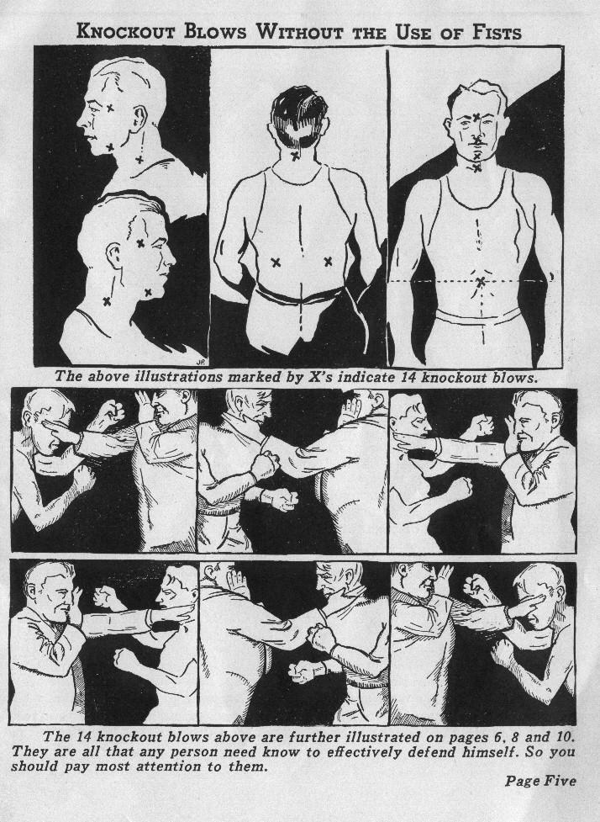
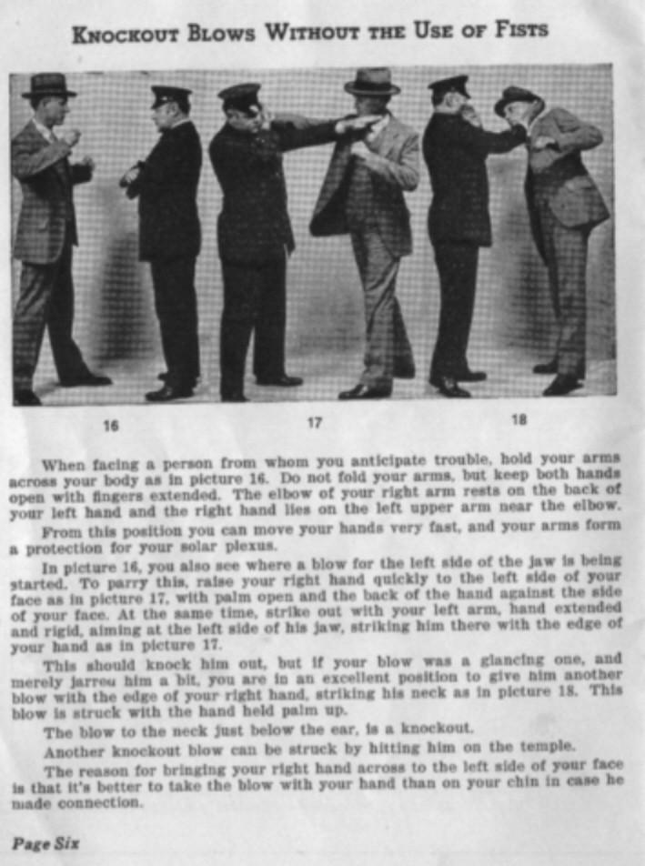
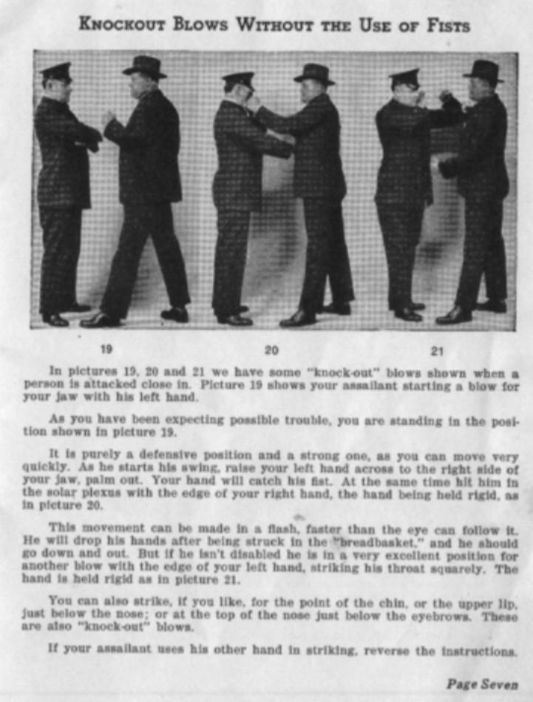
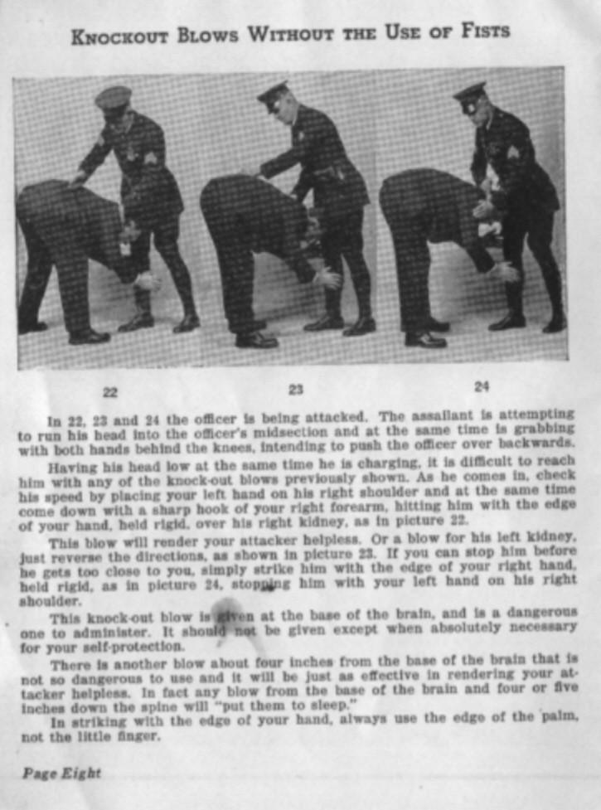
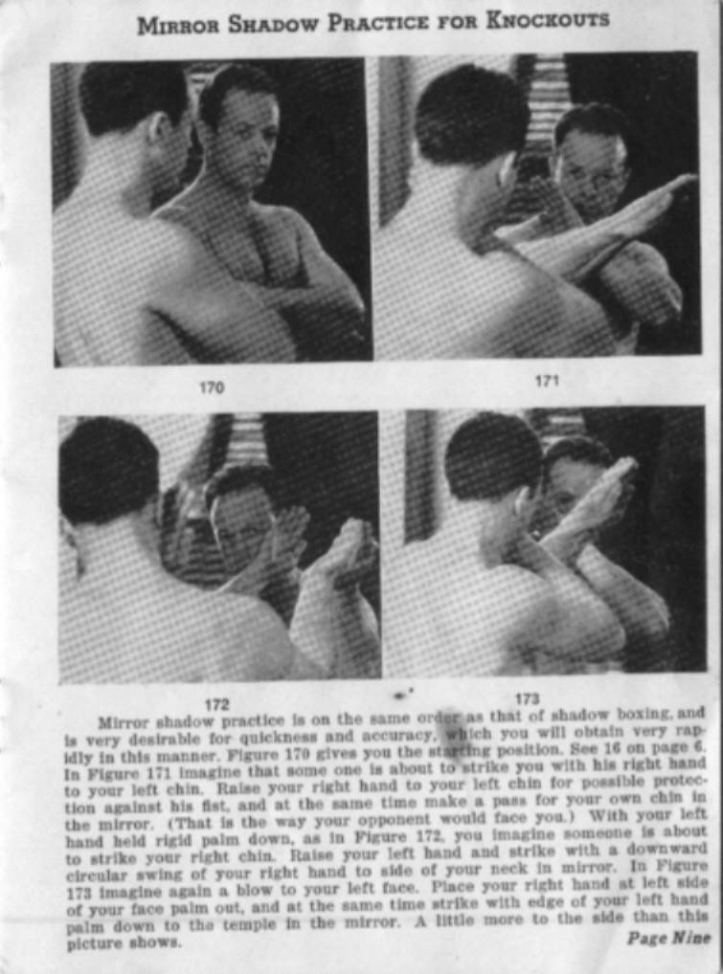
THE EDGE OF HAND BLOW
From Jiu-Jitsu Combat Tricks by H. Irving Hancock, 1904

From Chapter one:

"For instance, the Japanese does not strike with his clenched fist, but with the inner or little finger edge of the palm. This edge of the palm, then, must be put in the most favorable trim for severe attack. The edge must be hard --- capable of inflicting injury and of enduring sharp concussion.

For training the edge of the hand thus there is a very simple method that calls for time and patience. Strike the edge of the hand lightly but repeatedly against a wooden or similar surface. It is never necessary to increase the severity of this training blow, but at least twenty minutes daily should be given to this hardening process. For this no time need be taken from other occupations. When seated reading, exercise the edge of that hand which is not employed in holding the book. At times when neither hand is otherwise occupied the edge of both may be exercised simultaneously. The importance of so training the edges of the hands is not to be estimated lightly, and the toughening should be followed diligently for some months. The harder the edge of the hand is made the more effective will be the blows struck with it, and with the least exertion on the part of the combatant."

From chapter three:

"In Chapter 1 reference has been made to the fact that the Jiu-Jitsian does not employ his clenched fist in striking blows, but uses the edge of his hand, generally the little finger edge. This does not mean the edge of the little finger, which should never be struck, but the edge of the palm on the little finger side. In striking, sometimes the palm of the hand is turned upward, and sometimes downward, just as the nature of the blow requires for striking most severely. In some instances, as in striking upward under the chin, the thumb edge of the palm is used, the thumb being folded downward over the palm.

Here is a list of the more important blows that may be struck with the edge of the hand:

Lower Leg--- Across the shin on either side, and well to the front; strike halfway up the lower leg

Upper Leg--- Strike halfway between knee and trunk, either across the front of leg, or at outside of leg somewhat to the front

Side Blow--- Squarely on either side of the lower trunk, in the soft part just below the last rib

Kidney--- Strike over this organ in small of back, in soft part just below last rib Wrist--- On either side, just back of the joint

Forearm--- On either side, halfway between wrist and elbow

Upper Arm--- Strike across the front of the biceps, or on outside of arm and well to the front; in either case point of striking to be midway between elbow and shoulder

Collar-bone--- In case of a close clinch, open at one side, strike with little finger edge of palm, hand almost perpendicular and fingers pointing up, on collar bone midway between breast-bone and point of shoulder. (Too sharp a blow will fracture this bone)

Shoulder--- A sharp downward blow on top of shoulder, midway between neck and point of shoulder (A blow that causes a good deal of pain and subsequent soreness)

Side of the Neck--- Midway between jawbone and collarbone

Back of the Neck--- Too dangerous. Do not employ, except in a case of "life or death". Instead, when striking from behind, use heel of hand, fingers pointing upward. Strike heel of hand just at the base of the skull, with a combined forward and upward movement. And even this blow is hardly less dangerous. Both blows are mentioned more by way of caution that they be avoided by the experimenting student

Blow across the Base of Spine--- Too Dangerous. Instead, employ blow over the kidney

All of the blows struck with the edge of hand are given smartly and with a good deal of force. In striking at throat or neck the right hand of assailant is used against the victim on his right side, instead of at his left, in order that the blow may be given more force."

[Thanks to "gnarlmaster"]
THE EDGE OF HAND BLOW
From Lightning Ju-Jitsu

N.Y.: New Power Publications, 1943.

Page 22-23

"EDGE-OF-THE-HAND-BLOW

To most people, the clenched fist has been the main weapon of attack or defense. But Lightning Ju-Jitsu makes use of other blows more precise, painful and deadly. The most frequent of these, the edge-of the-hand-blow, is delivered with the knife edge of the hand; that is, the outer or little finger side.

For a vertical blow, crook the arm at the elbow and swing it down obliquely with a swift, chopping motion. Keep the fingers rigid and close together (figure 11). Put your bodyweight behind the blow by rising to your toes; then flex your knees slightly at the instant of striking. Practice with either hand. Learn to strike so rapidly that your opponent cannot guess your intention.

For a horizontal blow, swing either hand out from the elbow in an arc. Keep the palm facing downward (figure 12).

Edge-of-the-hand blows are particularly effective in parrying an attacker's blow, in breaking his grip, in throwing him off balance, and in inflicting punishment.

Apply these blows upon:

1-The wrist (especially when a fist or weapon is being aimed at you) 2-The lower or upper arm
3-The sides of the body

Except in a life-or-death struggle, avoid striking the following vital points where serious or even fatal injury may result:

1-The larynx or Adam's apple
2-The back of the neck
3-The side of the neck
4-The kidneys or base of the spine"

[Thanks to "gnarlmaster"]
THE EDGE OF HAND BLOW From Effective Unarmed Combat by Malcolm Harris, 1972
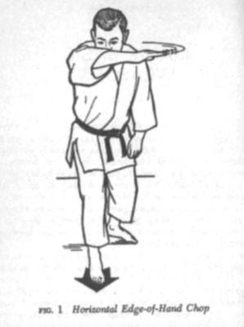

Pages 19-21

Edge-of-Hand Chop

The chop with the hand may be delivered either horizontally or vertically. A horizontal chop is started with the arm bent and the hand held, palm downwards, just above the far shoulder (figure 1). A vertical chop is commenced with the arm bent and the hand held just above the near shoulder. The hand is held with the fingers extended and close together, the thumb bent and resting comfortably near the base of the index finger (figure 2). The part of the hand that extends from the base of the little finger to the wrist is used to strike at the following target areas: trachea (wind-

pipe) in front of the neck; either side of the neck towards the front; the base of the skull at the back of the neck; and the solar plexus up under the rib cage, if not covered with heavy clothing. At the moment of striking, the hand and wrist are made tense and rigid with the fingers in perfect alignment with the forearm. Note that the thumb should not be extended so that it is almost at a right angle to the fingers, because it might then be grasped and wrenched back or punched back hard enough for it to be broken. Similarly, any separation of the fingers is potentially hazardous. In both horizontal and vertical methods of delivery, body weight should be behind the blow in order to obtain the most severe effect. This is done by advancing the leg on the same side as the hand which is delivering the chop and transferring the whole weight of the body on to this forward leg at the moment of impact.

Drawings from EFFECTIVE UNARMED COM
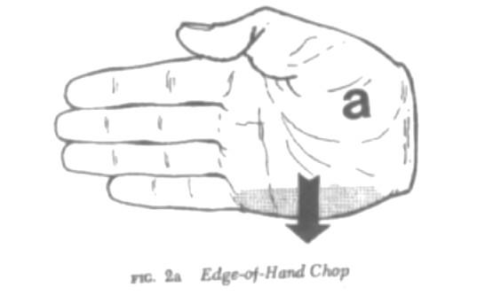
NO. 2 - CHIN JAB

Deliver this blow with the heel of your hand, full force, with the weight of your body behind it, and fingers spread so as to reach your opponent's eyes, as in Fig. 4. Always aim at the point of your opponent's chin (Fig. 5)

Deliver the blow upwards from a bent arm and only when close to your opponent. The distance the blow will have to travel will depend on the height of your opponent, but will seldom exceed six inches.
Never draw your hand back, thus signaling your intention of striking. From start to finish, make every movement as quickly as possible.

Remember that an attack, or an attempt to attack, with the knee at your opponent's testicles will always bring his chin forward and down.
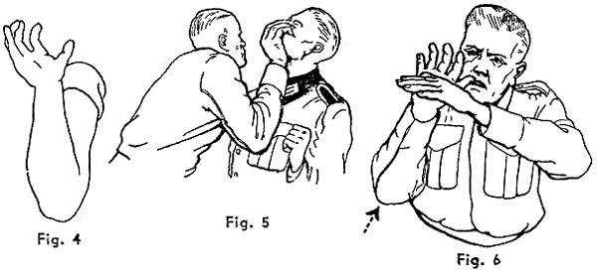

Note.- Practice this blow as follows: Hold your left hand at the height of your own chin, palm downwards; jab up quickly with your right, striking your left hand, as in Fig. 6.
THE CHINJAB
From Hands Off! Self Defense for Women by W. E. Fairbairn, 1942

Page number 7

No.4. How to Apply the "Chin Jab"

In Defense Holds No. 5, Being Strangled (Two Hands); No.8, Waist Hold From the Front; and No.10, Hair Hold (From Behind), it will be noted one of the methods is referred to as a "Chin Jab." This blow is struck with the base or heel of the palm of the hand at the "Point of the Chin," and, if applied correctly, is liable to render your assailant unconscious.

CAUTION: The "Chin Jab" should be used only when circumstances justify such drastic methods. Students are advised to practice at "Shadow Drill," not on their friends.

- Bend the right arm from the elbow, turning the palm of the hand to the front (Fig. 7).

- Bend the palm of the hand backwards as far as possible, extending the fingers and thumb, and keep them bent (Fig. 50 that, in the event of your missing your assailant's chin, they will reach his eyes, should the situation justify such drastic action.
Note: The force of this blow does not depend upon the strength of the person applying it, but upon keeping the palm of the hand bent backwards. This permits one to deliver a "rock-crushing" blow with a follow-through from the shoulder and no possibility of hurting one's own hand app1ying it.

- The position of the hand in Fig. 8 was selected as the best to demonstrate the relative position of the fingers, thumb, and palm of the hand. Students will find that a position somewhat as in Fig. 9 will be a more practical position from which to start this blow.
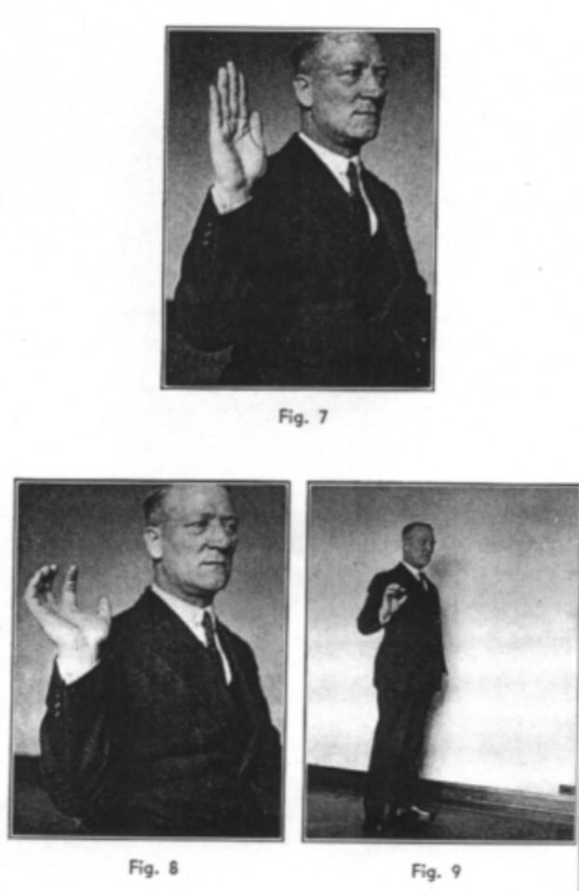
Page number 9

No. 5. Being Strangled (Two Hands)

Your assailant seizes you by the throat with both hands, forcing you back against a wall, Fig. 10.

Note: In the event of being attacked in this manner, drastic methods are called for and are justifiable. We strongly recommend the application of the "Chin Jab."

- Turn up the whites of your eyes to deceive your assailant and put him off his guard. Then suddenly shoot both your hands up inside his arms and strike him on the point of the chin-"Chin Jab."

- Keep your fingers and thumbs extended and endeavor to reach his eyes with the points of your fingers or thumb of one of your hands. Simultaneously knee him in the pit of the stomach, Fig. 10.
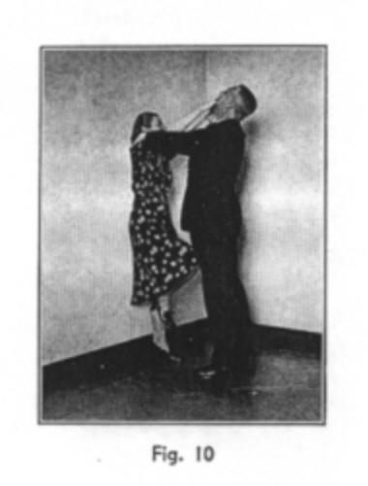
Page number 13

No. 8. Waist Hold (From in Front)

Your assailant seizes you around the body from in front, leaving your arms free.

- Place your left hand around and in to the small of his back, simultaneously striking him on the point of the chin ("Chin Jab"). If necessary, knee him in the stomach, Fig. 13.

- Seize his neck with both hands, fingers touching behind, thumbs in front, the points one on either side of the "Adam's apple." Force inwards and upwards with the points of your thumbs and towards you with the points of your fingers-then jerk his head sharply backwards, Fig. 14.

Note: The average person is very susceptible to the discomfort caused by this neck hold as shown in Fig. 14, and students are advised not to practice it on their friends.
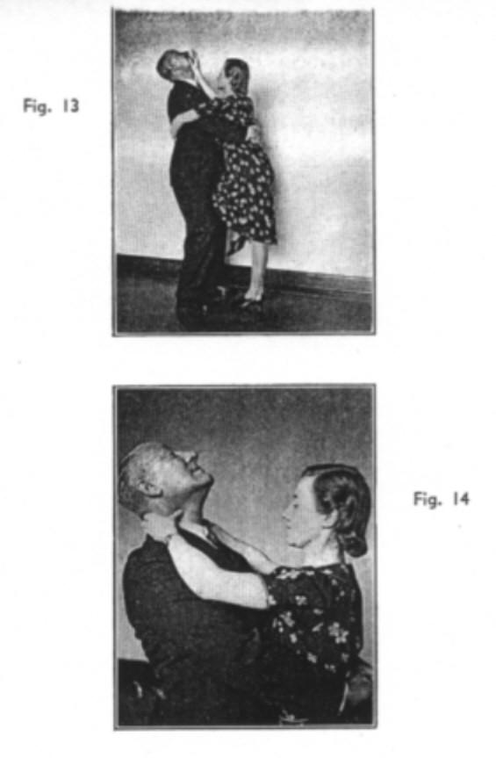
Page number 17

No. 10. Hair Hold (From Behind)

Your assailant seizes you by the hair, from behind, with his right hand.

- Bend backwards and seize his hand from above, keeping a firm grip with your hands, force your head into his hand to prevent him letting go, Fig. 17.

- Turn in towards your assailant; this will twist his wrist.

- Force your head up and bend his wrist inwards, away from his elbow, Fig. 18.

Note: The success of this method depends mainly upon the speed with which it is completed and the continuous upward pressure of your head against his hand, combined with the firm grip on his hand by both of yours.

If, when you are in the position shown in Fig. 18, your assailant attempts to use his left hand against you, immediately release your hold with the right hand and strike him on the point of the chin ("Chin Jab"), Fig. 19.
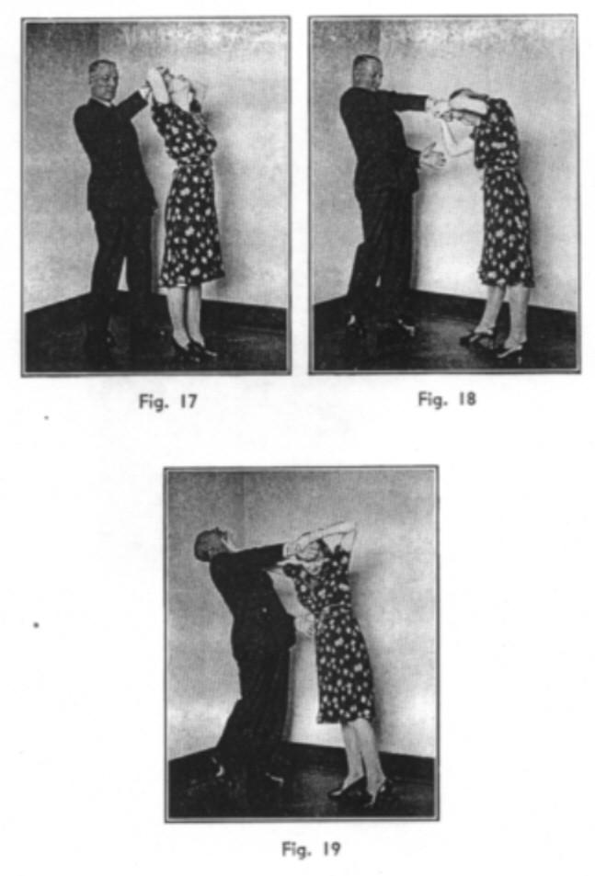

Thanks to "gnarlmaster”
THE CHINJAB
From Scientific Self Defense by W. E. Fairbairn, 1931

No. 5. --- WAIST HOLD. FROM IN FRONT.

Your assailant seizes you around the body from in front, leaving your arms free.

- Strike his chin a hard upward jab with the heel of your right wrist (Fig. 10).
- Seize his neck with both hands, fingers touching behind, thumbs in the front, one on, each side of the "Adam's Apple." Force inwards with the point of your thumb and jerk his head sharply backwards (Fig. 11).
- Seize the back of his neck between the thumb and the fingers of your right hand and force him to the ground (Fig. 12).
- Kick him on the shins.
- Knee him in the testicles or stomach.
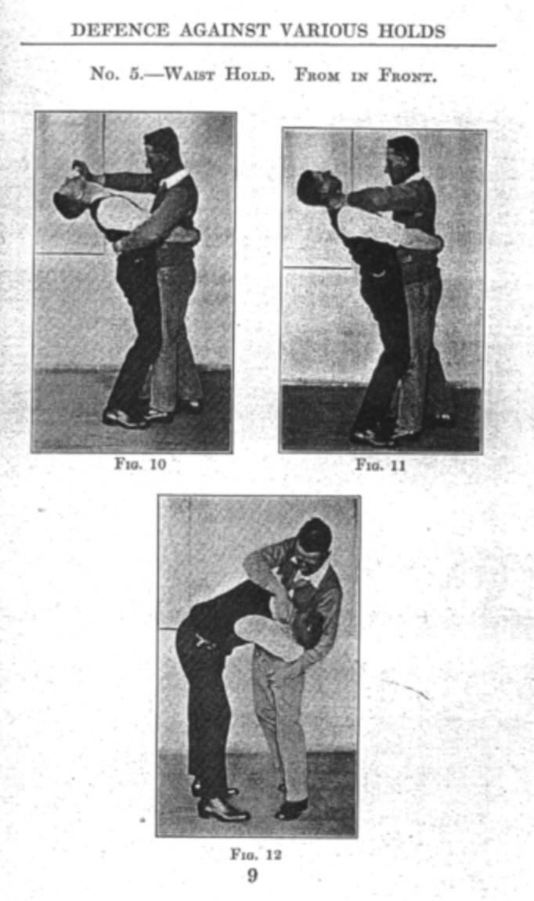

Thanks to "gnarlmaster"
THE CHINJAB

From Cold Steel

by John Styers, 1952

Page 107

The heel of the hand. The wrist is locked and firm in all attacks with the hand. This is one exception. With the fingers extended, bend the whole palm back in the same position as when pushing of leaning palm first against a wall. The palm in this manner makes a battering ram of your forearm. The natural seat of your palm fits perfectly under the chin of an opponent. When in close, aim an uppercut at your opponent's solar plexus or chest, the heel of the hand will sweep up in a natural arc. The heel of your hand, directly backed by the bones of your forearm, will connect with the impact of a rock. Close your teeth and try it gently on yourself.
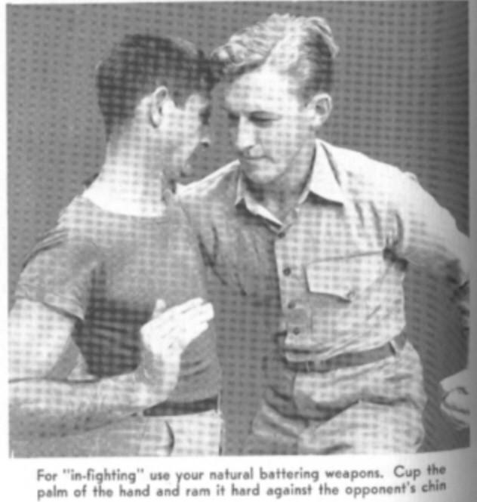
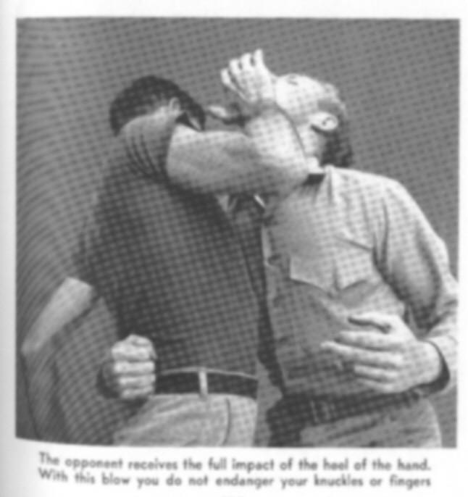
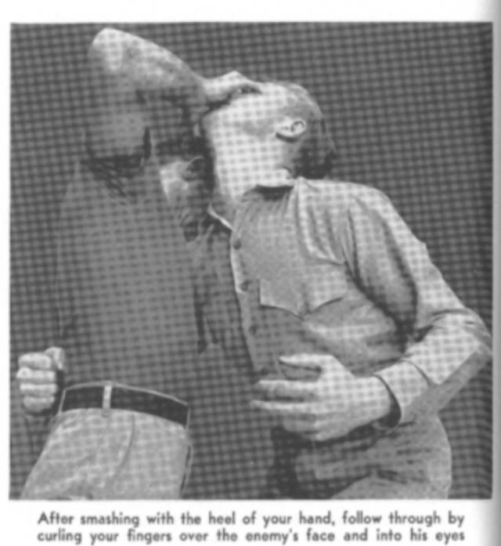

Thanks to "gnarlmaster"
Carl Cestari
Proper execution of the Tigers Claw

--------------------------------------------------------------------------------

Extend the hand in a complete line with the forearm, just as one would in forming the edge of hand blow.

Bend the wrist upward at NO more than a 45 degree angle.

Simply tense and "hook" the fingers slightly. This resembles a Tigers Claw.

This blow is used JUST like a fast and hard LEFT JAB. Piston like, NO fish tailing!

Target the eyes with the "clawed" fingers. As the fingers make solid contact(and it DOES NOT matter if you strike the eyes or NOT!) the wrist will NATURALLY flex and the PALM will crush the nose and the HEEL of the hand smash the chin. At least that's the ideal.

Now an assailant MUST come into your range to do YOU any damage. Whenever he DOES...........TIGERCLAW! Once, twice three times........whatever. Get the job done.

Take a lesson from boxing here: How often is a good left lead blocked or avoided? Not often at ALL. Any boxing coach worth his salt knows the left is your bread and butter so to speak. As it is with the Tigers Claw.

And...............old boxing cliche' - "lead with speed - follow with power".

Re-read my post under Essentials for more info on the Tigers Claw.

Hope this helps!

Carl 3/18/02
NO. 3 - BOOT (SIDE KICK)

With a few exceptions, you should always kick sideways, for you arc thus able to put more force behind your blow and can, if necessary, reach farther.

Turn your right side to your opponent, putting the weight of your body on your left foot. Bending your left leg slightly from your knee, raise your right foot two to four inches off the ground, as in Fig. 7. Shoot your right foot outwards and upwards to your right, aiming to strike your opponent's leg just below the knee-cap.

Follow the blow through, scraping down your opponent's shin with the edge of your boot from the knee to the instep, finishing up with all your weight on your right foot, smashing the small bones of his foot. If necessary, follow up with a chin jab with your left hand (Fig. 8).

Note. - Where the kick is to be made with the left foot, reverse the above.
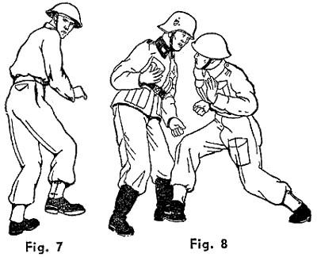
NO. 3A - BOOT DEFENSE
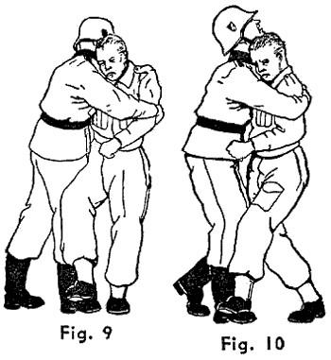

Your opponent has seized you around the body from in front, pinning your arms to your sides.

- Having put your weight on one foot, raise the other and scrape your opponent's shinbone downwards from about half way from the knee, finishing up with a smashing blow on his foot (Fig. 9).

- An alternative method to Fig. 9, permitting you to use the inner edge of the boot, is shown in Fig.

Note A. - Whether you should use the outside or inside of your boot will depend upon how the weight

of your body is distributed at the time. Provided that you are equally balanced on both feet, you can use either; otherwise, use the one opposite to that on which you have your weight.
Note B. - lf seized from behind, stamp on your opponent's foot with the heel of either boot, turning quickly and following up with a chin jab with either hand.
NO. 3B - BOOT ("BRONCO
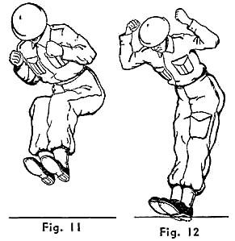
KICK")

Your opponent is lying on the ground.

- Take a flying jump at your opponent, drawing your feet up by bending your knees, at the same time keeping your feet close together (Fig. 11)

- When your feet are approximately eight inches above your opponent's body, shoot your legs out straight, driving both of your boots into his body, and smash him.

Note. - It is almost impossible for your
opponent to parry a kick made in this manner, and, in addition, it immediately puts him on the defensive, leaving him only the alternative of rolling away from you in an attempt to escape. Further, although he may attempt to protect his body with his arms, the weight of your body (say 150 pounds), plus the impetus of your flying jump (say another 150 pounds), will drive your heels into your opponent's body with such terrific force that you will almost certainly kill him. Steel heel-plates on your boots will make his attack even more effective.

Practice this kick on a dummy figure or on the grass as in Fig. 12.

www.gutterfighting.org/techniquesCC.html

